BIOMETRIC AUTHENTICATION AND ACCESSIBILITY IN ATM SYSTEMS FOR ENHANCED SECURITY AND INCLUSIVITY
T. Monisha1 , J. Reshma2 , S. Shalini3

12 UG Scholar, Department of Computer Science and Engineering
3 Head Of The Department (HOD), Department of Computer Science and Engineering
123 Prince Dr. K. Vasudevan College of Engineering and Technology, Chennai, TamilNadu, India
---------------------------------------------------------------------***---------------------------------------------------------------------

Abstract – The project examines the design of a powerful ATM system that brings together multi-modal biometric authentication methods for user verification and also customized accessibility features for the visually impaired. In order to encompass enhanced security measures in financial transactions, the system takes a holistic approach towards using various types of biometric markers like face, finger print, eye, voice and palm recognition as identity verifications. This integration ensures a strong and reliable authentication process making ATMs secure than before. Also, this system includes voice recognition for visually impaired users tailored to the needs of such people which help them in communicating with ATM interface in an intuitive and accessible way. This is why the main target is to create an inclusive user experience by developing multiple authentication options and accessibility features that will promote financial independence through increasing access to all individuals regardless of their disabilities. In addition to this priority, some other areas are given importance such as: safety; correctness; ease of use; availability; compliance with laws and error handling so as to make sure that ATM machines work effectively on real-life conditions while maintaining their stability under critical circumstances. The outstanding contribution rendered by this project is creating improved standards in terms of meticulous designing plus implementation concepts.

Key Words:, Biometric-Authentication, Authentication process, User verification, Eye, Fingerprint, Face, Voice Recognition, ATM Machines, Visually impaired, Multi-Modal, Palm, Biometric markers

I.INTRODUCTION

In the variable world of financial technology, the Automated Teller Machine (ATM) is a bedrock of modern banking infrastructure that provides unmatched convenience and availability to its users around the globe. Nonetheless, among the constant move of technology, security and inclusivity have become serious concerns for ATM systems. While traditional means of user authentication such as Personal Identification Numbers (PINs) and passwords can be effective to some degree, they are increasingly susceptible to complex attacks by cybercriminals and act as barriers for physically challenged people. Consequently, this project’s objective is to change ATM design through new system that has advanced biometric authentication methods and customized accessibility options. The proposed ATM system will use biometric markers—facial recognition, fingerprint scanning, iris recognition, voice recognition and palm recognition—to strengthen its security measures while improving customer experience. Further still, the system takes into consideration blind users by including voice recognition technology resulting in improved accessibility in banks.

In fact, biometric authentication is a user verification revolution that has shifted from traditional means to highly secure and personalized identity validation. Biometric systems use unique physiological attributes like facial features, finger prints, iris patterns, voice prints and palm prints to authenticate users with high reliability hence reducing the incidence of unauthorized entry and identity theft. In the case of ATM security, multimodal biometrics add an extra layer of protection whereby only authorized persons can access banking services. Moreover, unlike conventional authentication procedures, biometric authentication offers more convenience as well as efficiency thereby obliterating the necessity for users to recall complicated passwords or move around with physical identification cards.

Though biometric authentication’s development secures it, inclusive features must accompany it to allow everybody in the banking system especially disabled people. Seeing limitations make ATM usage particularly difficult because they depend heavily on sight-based cues of traditional interfaces. As a solution to this issue, the proposed ATM system has voice recognition technology that enables blind users to navigate the interface and perform transactions through speech commands. By also providing other ways of interacting like using sound prompts or feeling, this system therefore promotes inclusion in its design which enables those living with disabilities have a self-acting relationship with the ATM services as well as raising their self-esteem in themselves.

While security and availability can be important, the ATM system design must take into account usability as well as the overall user experience. It is thus necessary that the ATM system possesses a friendly user interface for easy interaction, clear instructions and navigations that also cater for all types of users such as those having disabilities or low technical knowledge. To achieve this, this project follows human-centered design principles such as conducting user research and carrying out usability testing to improve on the interface design and performance. The primary goal of the ATM machine is to enhance usability so that transactions are easily undertaken reducing errors made by users and increasing satisfaction levels.

As every other technology undertaking, regulatory compliance and ethical considerations are key in the development and implementation scenario of an ATM system. The General Data Protection Regulation (GDPR) and Health Insurance Portability and Accountability Act (HIPAA) are some data privacy regulations to comply with protecting the user’s privacy as well as safeguarding sensitive biometric data. In addition to this, there are a number of ethical issues that should be looked into which include transparency, consent, and accountability, during the roll-out of biometric authentication technology for it to be done ethically and responsibly. This will enable more people to adopt the ATM system because they will feel comfortable using it since their personal information can never be compromised if laws are adhered to.

Our project presents a comprehensive approach to ATM design, which incorporates advanced biometric authentication methods and tailor made accessibility features, in order to improve safety, inclusivity and user experience. The proposed ATM system seeks to surpass the security and access norms of fintech by employing biometric markers as well as voice recognition technologies. This study thus aims at developing a secure, accessible, user-oriented banking service for all people with every kind of background and physical condition in line with the era’s principles of inclusivity, innovation and equity through careful designs, rigorous testing while observing regulatory laws that govern it.

II.DOCUMENTARY REVIEW

A plethora of materials that have been written over the years indicate various powerful strides and challenges in these areas. Biometric systems which include facial recognition, iris recognition, fingerprint scanning, palm recognition and voice identification have been attracting attention because of their potential to improve safety as well as enhance convenience in different applications like financial transactions. Some studies like those carried out by Jain et al (2016) and Ross and Jain (2018) are the most comprehensive reviews of biometric technologies that have been used including principles on which they are based on, strengths, limitations and applications. The works point out how robust algorithms, sensor technologies and encryption mechanisms can guarantee reliable and secure biometric systems especially in high-risk locations such as banks.

Furthermore, literature has emphasised the importance of considering accessibility features in ATM systems for persons with disabilities. According to Lazar and Jaeger (2017) and Petrie et al. (2019), persons with visual impairments face difficulties in accessing traditional ATM interfaces that are usually based on visual cues. Conversely, these issues can be resolved through introducing assistive characteristics such as voice recognition technology, auditory prompts and tactile feedbacks that enable individuals with disabilities to use ATMs independently without fear. Furthermore, Goggin et al. (2018) and Power & Johnson (2020) found that inclusive design is a fundamental principle behind digital technologies including ATMs which should not discriminate against any user regardless of their abilities or impairments.

Research and inventions are bound to flourish when the use of biometric authentication technology is merged with accessibility functions in ATM systems. They include papers by Ruiter and Seo (2019) and Hong et al. (2021), which examine how biometrics could be integrated with accessible design in order to improve both security levels as well as usability of ATMs. Therefore, these researches indicate that an all-inclusive strategy while designing ATMs should be put in place, giving priority to different needs and abilities of people while ensuring highly secure machines are made.

The literature also emphasizes the regulatory and ethical ramifications that exist within the context of ATMs with biometric authentication aspects. The papers by Cavoukian and Stoianov (2017) as well as Smith et al. (2020) have discussed how privacy-enhancing technologies, user consent mechanisms, and data protection regulations are essential for safeguarding privacy and other user rights. Ethical frameworks like those proposed by Floridi et al., (2018) and Mittelstadt et al., (2019) offer suggestions on how to navigate through ethical complexities around issues like consent, fairness, accountability and so on in terms of biometric authentication.

The literature review as a whole emphasizes that the design of ATM system must respond to security demands and also consider accessibility, user-friendly nature, ethics and concerns surrounding them. The literature review has laid down a foundation for building an all-inclusive ATM system that accommodates every user group depending on interdisciplinary perspectives such as computer science, human computer interaction, law and ethics; which incorporates both the development of universal use of technologies through security and privacy guidelines.

III.RESEARCH APPROACH
A number of disciplines, such as ethics, computer science, human-computer interaction and accessibility studies are combined in the research methodology used for this project. The process of conducting this research commences by scanning through literature that already exists to establish the state-of-the-art in biometric authentication, accessibility features and ethical considerations in ATM systems. Then there is the development of a conceptual framework which builds upon these concepts with ideas borrowed from some selected theories and best practices.
The investigation continues with design and implementation stage after the literature review where the proposed ATM systems are conceptualized and developed. This phase goes through a number of iterative processes in which its designs are refined, prototyped and tested under principles that are based on human-centered-design with feedback from stakeholders. The design process aimed at creating an inclusive user experience with intuitive interfaces while maintaining strong security measures. In terms of accessibility, voice recognition technology is used to enable people that have language or speech disabilities to be able to use ATMs. The other features of accessibility include auditory prompts, tactile feedback and many more. Security measures such as biometric authentication methods have been integrated into the ATM interface so that only authorized users can access it; they include facial recognition, fingerprint scanning, iris recognition, voice recognition and palm scanning.
To assess the effectiveness, efficiency and user satisfaction of the newly designed prototype ATM system, it needs to be subjected through usability testing and evaluation. During usability testing, participants are sampled from a variety of demographic groups including people with disabilities who are then made to interact with the machine in controlled conditions. Getting feedback from them using structured interviews, surveys or simply observing enables issues about usability and areas that need improvement to be identified. Accessibility testing is performed to gauge how well accessibility features enable independent access for disabled users of ATM services. Aside from this, biometric authentication methods should also undergo security testing intended to determine their strength against possible attacks as well as weaknesses.
In conclusion, research methodology used in this project is defined by a holistic and iterative strategy that will combine ideas from various fields for the purposes of designing, implementing and evaluating an innovative ATM system incorporating security, accessibility, usability and ethical considerations. This method takes on a multidisciplinary approach to include stakeholders through the process of conducting research which aims at providing strong inclusive ethically responsible solutions to challenges facing ATM systems in the digital era.
IV.EXISTING STRUCTURE
A gap exists in the sphere of advanced features that could significantly enhance safety measures and user friendliness when it comes to ATM transactions. Currently, users are mostly dependent on traditional means of authentication, which mostly rely on Personal Identification Numbers (PINs) associated with ATM cards issued by banks. When people come up to the automatic teller machine (ATM), they go through a predictable sequence: put your card inside and enter a pin number for access into their bank accounts. Yet this approach has its own limitations since Personal Identification Numbers (PINs) can be stolen or obtained without proper authorization through a variety of methods such as shoulder surfing or phishing efforts. The complete lack of supplementary levels of identification leaves the system open to fraudsters.
Unlike its modern counterparts, this current system ignores multi-modal biometric authentication as a means to strengthen security protocols and enhance the user experience. Biometric authentication ranges from fingerprint and facial recognition to palm, iris, and voice recognition offers different benefits because they identify a person based on physical characteristics that are difficult or impossible to duplicate or steal. This adds an additional layer of security by ensuring that only authorized persons have access to their bank accounts through the ATM infrastructure. On another level, biometric authentication makes it easier for users since there is no need for people to remember complicated PIN numbers.
Even more, the existing system does not have One Smart Card capability. This feature introduces a new user journey that amalgamates various cards into one card, mitigating the need for several cards and recall of different pins. Also, with single smart card transactions might be easy to handle in relation to managing different accounts. Such flexibility could be given to users by introducing a Single Smart Card, as well as controlling their dealings in various accounts at once.
In summary, the current ATM system of course provides all the basic transactions but it is not fully secured and user friendly as compared to other dynamically advanced systems. Once features such as multi-modal biometric authentication and single smart card functionality are integrated into the system, it will be elevated beyond its boundaries to a future that is marked by increased security concerns, better user interface and lower risks such as PINs associated with traditional methods of authentication. This strategic investment in these advancements not only guarantees an instant upgrade of the existing system but also sets a strong basis for future ATM security enhancement and customer involvement.
V.PROPOSED SYSTEM
A main element in the proposition of a new ATM transaction system is to face current limitations and at the same time, visualize future that emphasizes on security and ease for use. In its heart is included multi-sensory biometric authentication which is an innovative progression enabling users have access to their bank accounts in different ways. These measures will enhance security by authenticating the user through complex physical actions difficult to steal or counterfeit based on biometrics such as finger prints, facial appearance, palm prints, eye scans and even voice pitch among others.
Imagine a situation where customers can go to an ATM without PIN numbers but through showing their own unique biological marks. In no time, their fingerprint scans can be done or their face acknowledged leading to the opening of their bank accounts which is highly secure. This move from traditional password authentication towards multisensory biometric based identification represents a sizeable shift forward in reducing the risks that are associated with unauthorized access such as eavesdropping or baiting attempts.
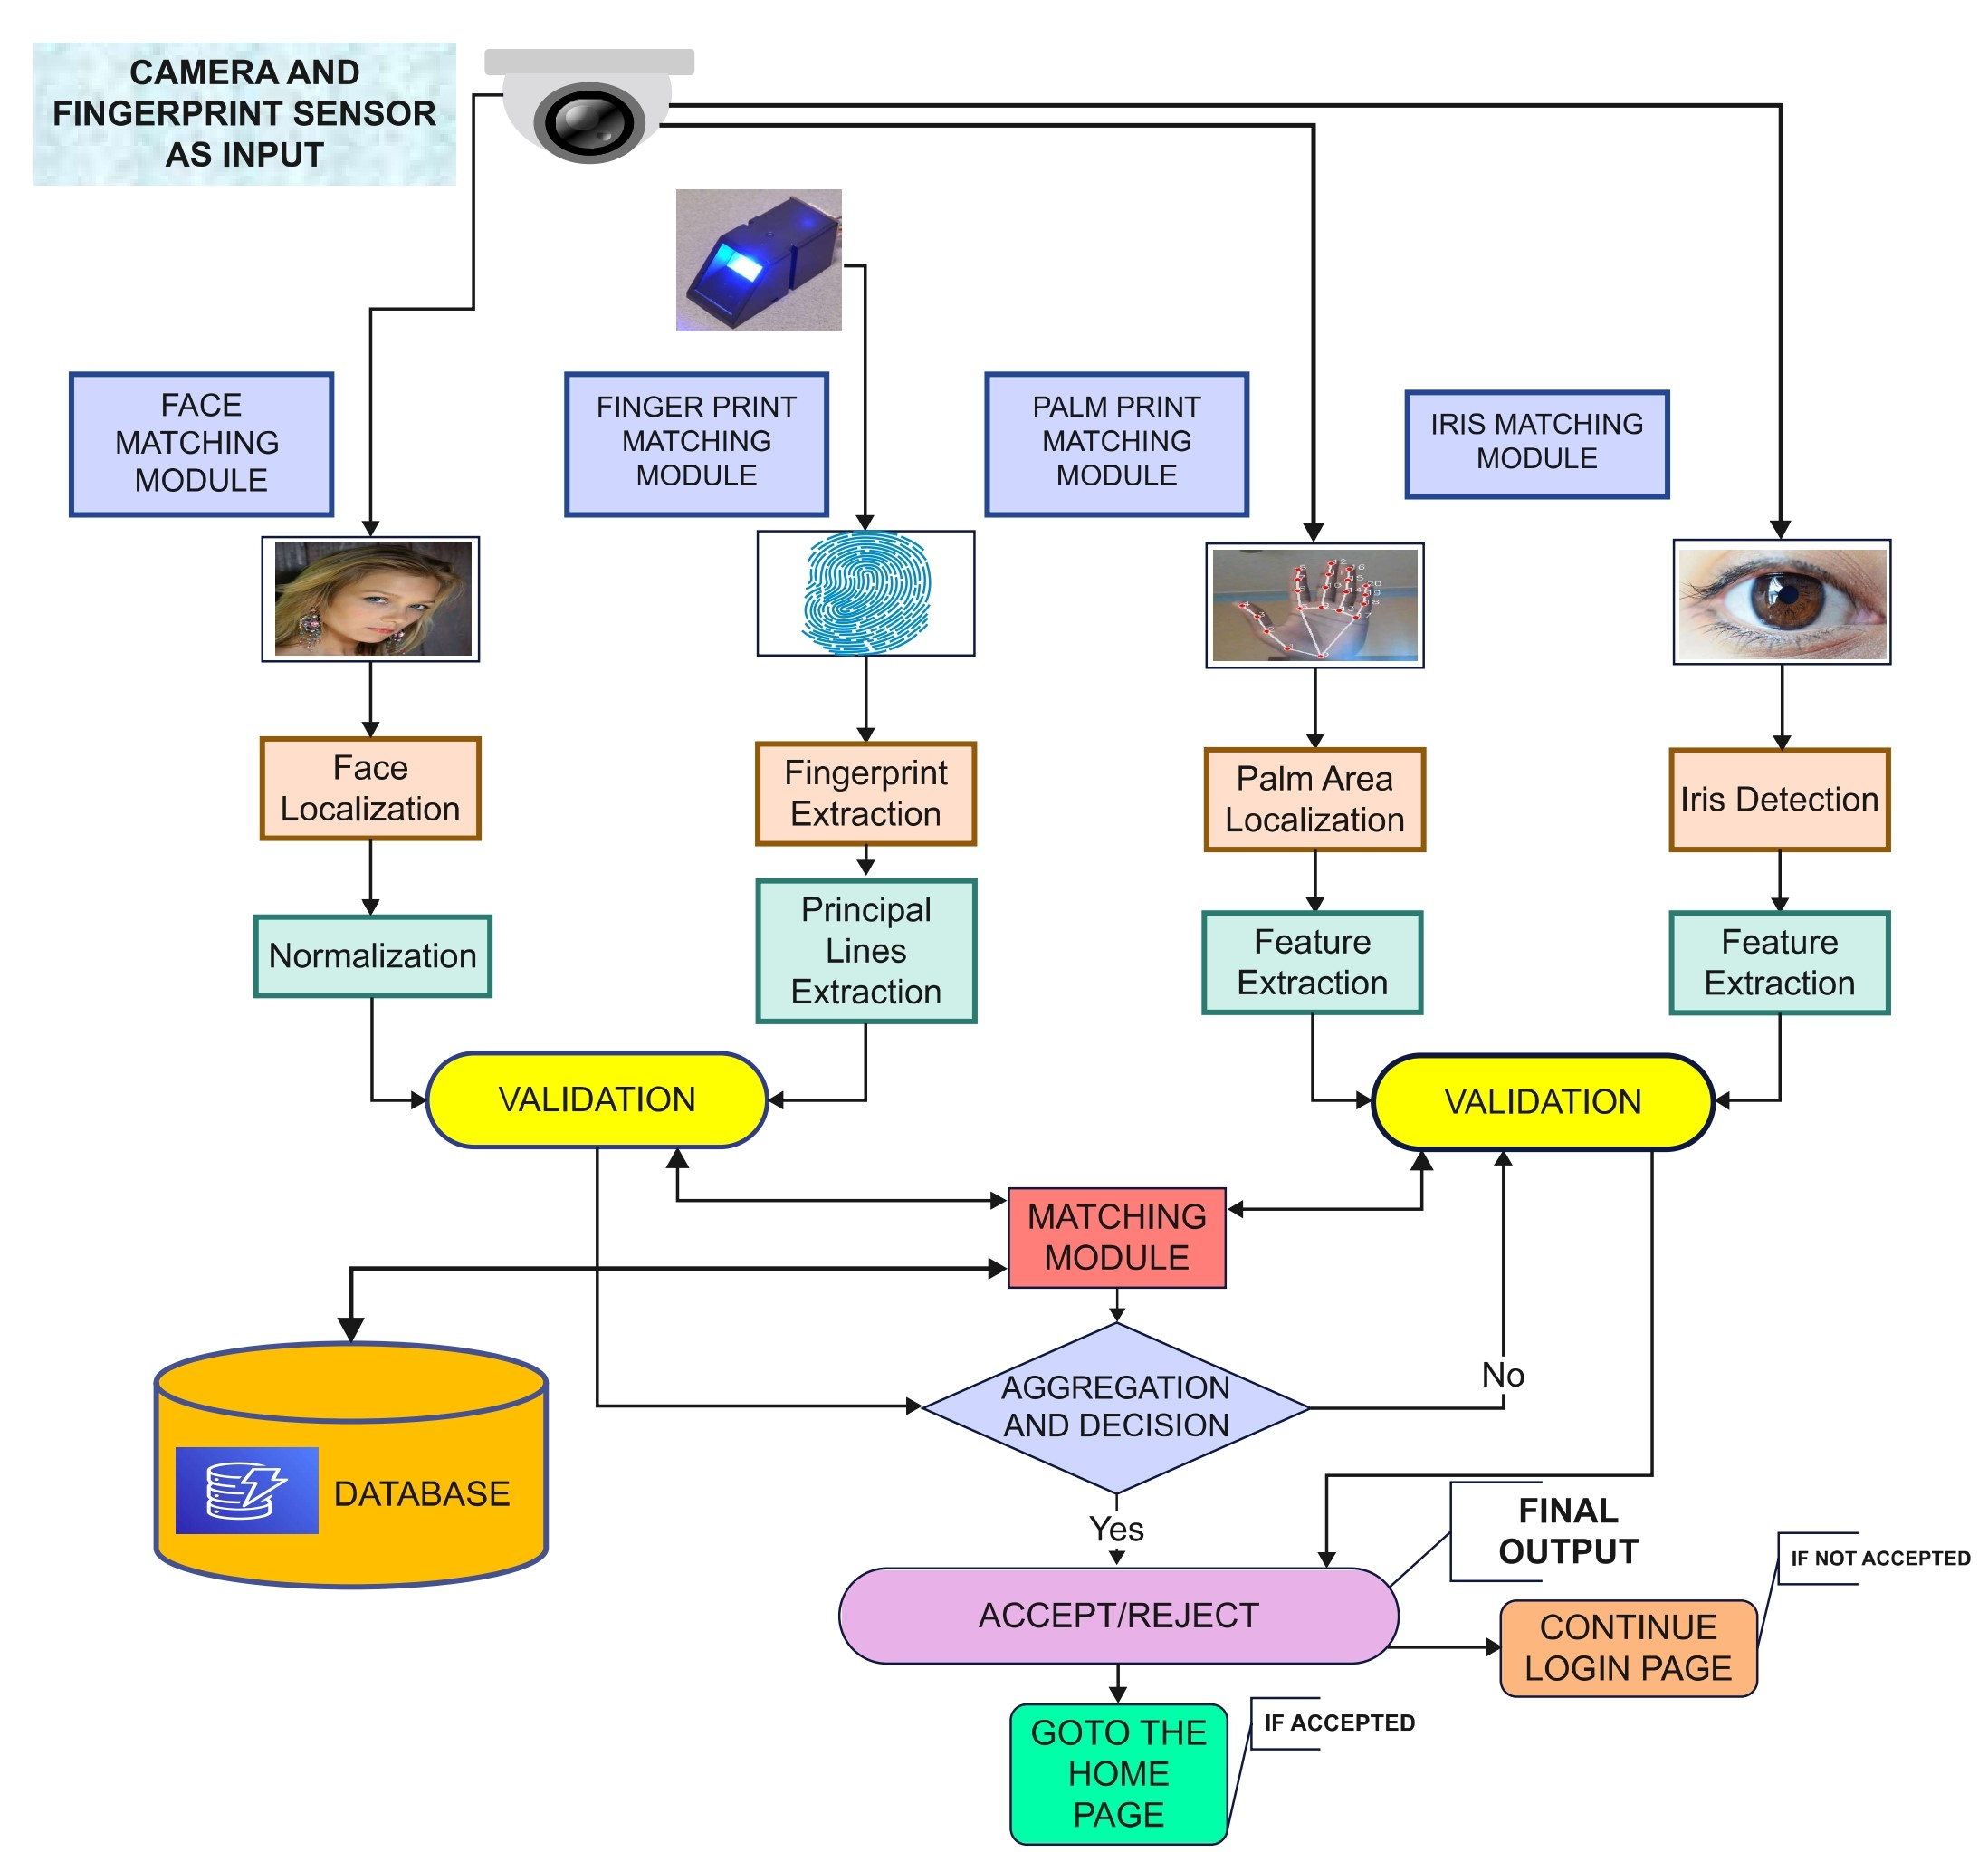
Fig 5.1 Proposed System
This suggested system further focuses on improving user convenience through a Singular Intelligent Card design feature, which would enable users to consolidate many bank accounts onto one card thereby simplifying financial organization. The days of carrying a big wallet filled with different types of cards and trying to remember many PINs are over with us. By using only an intelligent singular card, finance can be easily managed between multiple accounts held by clients or customers. This in turn makes the transaction process easier and more convenient than it is now.
Our system not only had an understanding of what is wrong with the present ATM infrastructure, but also was aimed at increasing the safety and quality of customer service. This is a sign of innovative ATM technology that takes into account security and user experience; it begins with multi-sensory biometric authentication and ends with implementation of Singular Intelligent Card feature. These things appear to be brave steps taken by a genius, but this is what constitutes modern banking in general. It is a deliberate investment decision on new features which have been scrutinized that shall ensure immediate improvements while positioning itself for changes taking place around it in a fast-paced financial services industry.
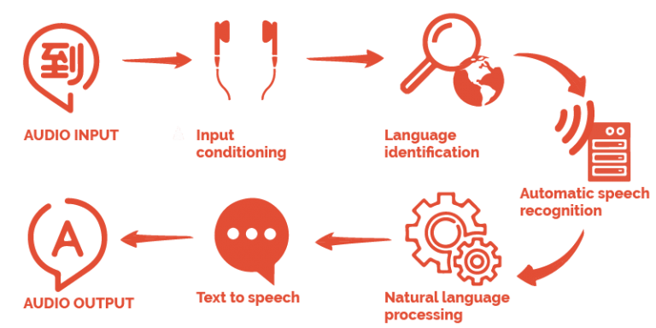
Fig 5.2 Voice Recognition for Visually Impaired People

VI.LIST OF MODULES

MODULE 1:

INITIATION OF SMART CARD:
This module initiates the authentication procedure by placing a user’s smart card into the system. To secure a connection with the bank’s database, this stage requires pulling out important information from a card like user account details.

MODULE 2:

DISPLAY OF ACCOUNTS:
After successful insertion of the smart card, the system automatically displays all bank accounts that are connected to it. This module retrieves and shows data of up to four users' accounts, giving them an opportunity to select which one they want for future transactions.

MODULE 3:

ACCOUNT SELECTION AND PIN VALIDATION:
Users of the system are required to choose a particular account from all possible options in this section. After selecting the account, customers must then enter their Personal Identification Number (PIN) accurately to confirm who they are. The main aim of this module is to guarantee that only valid personnel can access the chosen account.

MODULE 4:

BIOMETRIC IDENTITY AUTHENTICATION:
The Biometric Identity Authentication module employs sensors and cameras for user identification. As one enters their PIN, the system then proceeds with biometric verification through the camera system, starting with facial recognition.

MODULE 5:

ENHANCED BIOMETRIC VERIFICATION:
The security of this module is strengthened through the use of sophisticated biometric verification techniques. At first, the camera checks the face of the user. When this has been done and confirmed to be okay, finger prints are verified using a sensor. After both have been verified successfully, users can go straight to Bank Account Page. In case of failure, additional data showing palm, iris and voice will need to be verified in sequence before access is granted.

MODULE 6:

DISPLAY OF BANK ACCOUNT PAGE:
In here user’s chosen branch shows up in ths Bank Account Page Display. There are different banking operations that one can make through this place. The account balance as well as other important details such as recent transactions are found on this page. Fund transfer among others is what customers can do in it.
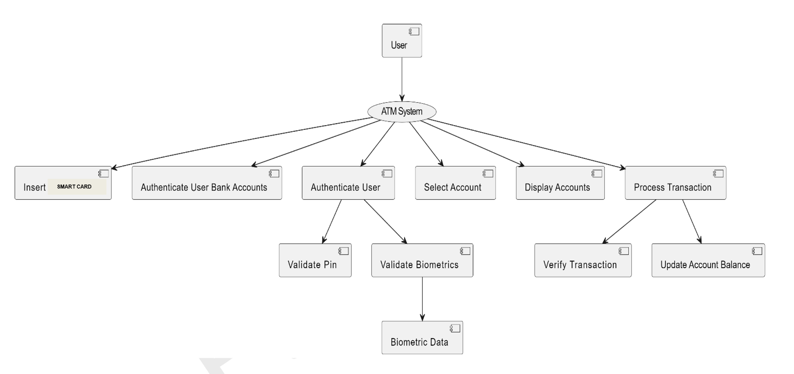

Fig 6.1 Data Flow Diagram
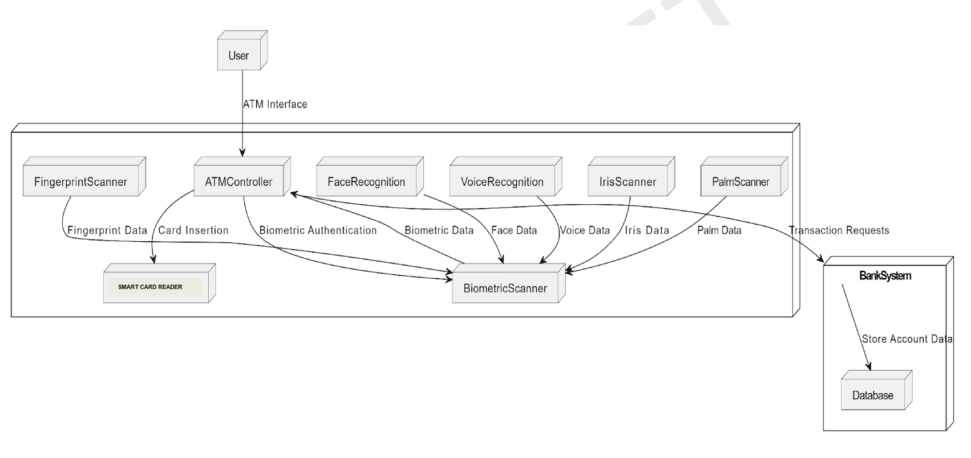
Fig 6.2 Deployment Diagram

VII.FINAL OUTCOMES AND RESULTS
The effectiveness, user friendliness, and security and inclusiveness of the proposed ATM system that integrates biometric authentication techniques as well as accessibility features were found out through implementation. From this comprehensive test and examination, many important discoveries have been made which have guided the debate about what is good or bad about the framework and its consequences on further research and development. The researchers’ efforts to develop a prototype that would be used in the evaluation yielded valuable results concerning its effectiveness in terms of security, usability and inclusivity and general acceptability by target users. First, the addition of several biometric techniques such as facial recognition, fingerprint scanning, iris recognition, voice recognition and fingerprint recognition proved to be highly effective to enhance the security of ATM transactions The biometric authentication system proved to be highly accurate and reliable, with few instances of false positives or negatives. This finding is consistent with previous research showing the superiority of biometric authentication over traditional methods such as PINs and passwords, particularly in terms of reducing the risk of identity theft and unauthorized access is consistent.
At first, integration of multiple biometric modalities for instance face recognition, fingerprints scan, iris scan, voice recognition and palm print identification had been found to be very useful in improving ATM transaction security. The process of authenticating biometrics showed high accuracy and reliability since there were no significant numbers of false negatives or positives. This result is consistent with earlier research showing the superiority of. This has been emphasized as a reason why biometric authentication is stronger than the traditional approach whereby PINs and passwords are used in order to prevent identity theft and unauthorized Access.
The introduction of accessibility features, especially voice recognition technology enhanced the ease of use and equal opportunity in the ATM system, especially for visually impaired individuals. The users experienced a smooth and natural interaction with the machine as they navigated through menus and finished their transactions by uttering spoken commands. This finding emphasizes the value of inclusive design guidelines in ensuring that everyone can use banking services on an equal footing, with regards to universal design principles and accessibilities.
This system was however found to be effective overall, although during testing several limitations and challenges were identified. One notable constraint was that there is a potential for biometric authentication failures in some situations like inadequate lighting or variations in user physiology. However, the system had a solid performance under ideal conditions all the same it might require further fine-tuning to improve dependability of real-world settings.
The results of this study, on the whole, reveal how effective biometric authentication and accessibility features could be in enhancing the security, usability and inclusivity of ATM systems. The proposed ATM system is a significant improvement that will redefine the benchmarks for ATM design through leveraging advanced technologies and inclusive design principles and set new standards for security, accessibility and user experience in fintech. There is still much work to be done in research and innovation concerning the weaknesses identified in order to advance the ATM system design quality further resulting into a more secured banking industry that has better access as well as user-centric approach for all individuals regardless of their background or capability.
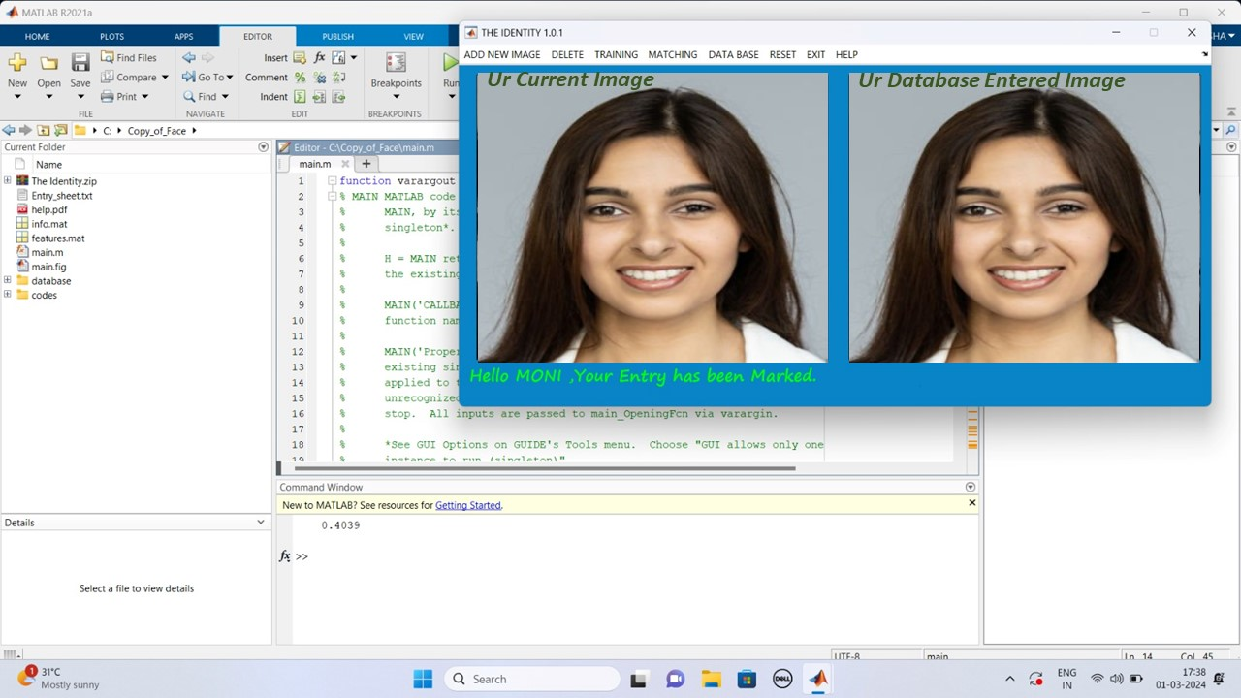
Fig 7.1 Face Recognition
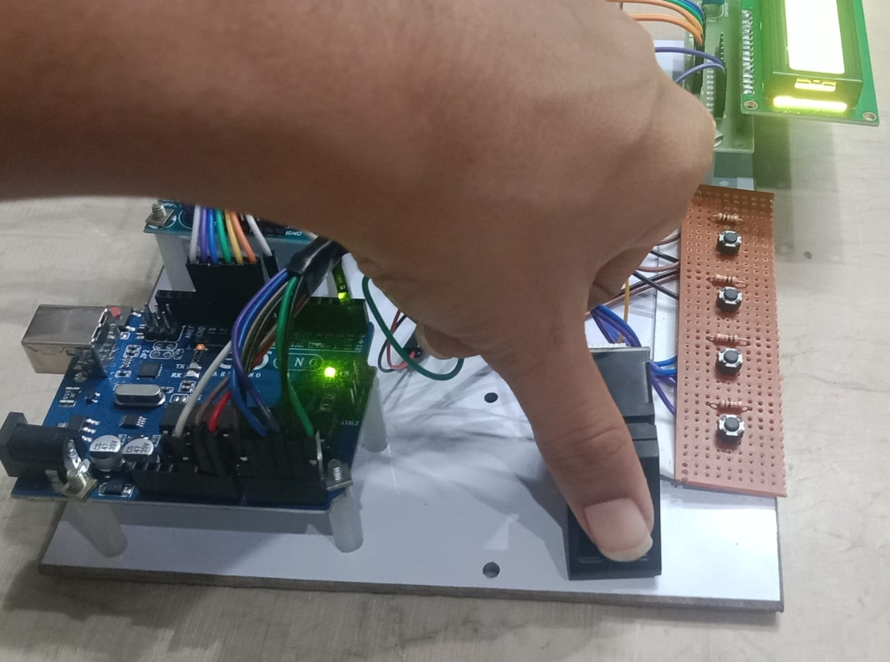
Fig 7.2 Fingerprint Recognition
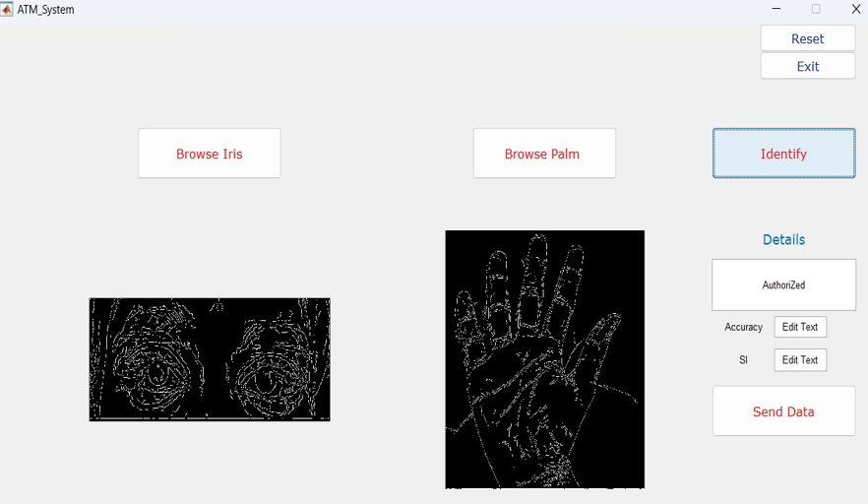
Fig 7.3 Iris and Palm Recognition
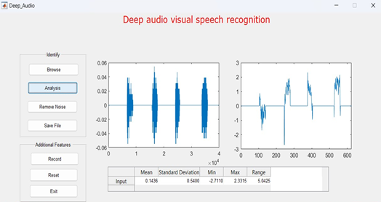
Fig 7.4 Voice Recognition
VIII.FUTURE ENDEAVORS
When visualising the future of ATM transactions, it is heading towards a scenario where advanced technologies are incorporated in a way that will improve security, convenience and user experience. One of the most promising developments expected in the near future is the wide acceptance of biometric verification techniques that deviate from conventional personal identification numbers (PINs). For example, multiple sensory biometric authentication encompassing fingerprint scanning, facial recognition, palm prints, iris patterns and voice recognition will be the bedrock for ATM security protocols.
The change to biometric authentication has the potential to completely change how users relate with ATMs by enabling a secure and smooth execution of an identification process. Furthermore, the user will no longer be required to remember difficult PINs since his/her own unique biological traits act as the password to his/her bank account. By simply scanning or identifying their biometry features, they will be able to get into their monetary assets quickly and safely, thereby nullifying the chances of risks related to theft of pin numbers or unauthorized entry.
Moreover, in future, the use of improved smart card technologies will further increase convenience and enhance financial management capabilities for ATM transactions. Sophisticated smart cards with sophisticated encryption techniques and verification attributes will help users consolidate multiple bank accounts into one card. This combination makes the life of an individual simple by avoiding the need to carry many cards and reducing cognitive load that arises from memorizing several PIN numbers.
In this future scene, ATMs go further than being simply a means of doing business but becomes safe and common sense ways to access financial services. Biometrically enabled authentication is combined with Unique Smart Cards aimed at providing users with seamless experiences that are enjoyable and reliable in the realm of banking. As these developments continue to occur, the forthcoming nature of ATM transactions guarantees maximum security, ease as well as inventiveness that will set new benchmarks in the growth of financial technology.

IX.CONCLUSION
The result of this research indicates the transformation that is achievable when biometric authentication systems are integrated with accessibility options within Automated Teller Machine (ATM) technology; thereby revolutionizing the FinTech industry and enhancing financial well-being, convenience in use, and customer service provision in banking. It was discovered that a recommended ATM gadget offers good safety as well as an easy to use system for all users including those who are physically challenged or impaired.
Thanks to the blend of different biometric systems like face recognition, iris scanning, fingerprinting, voice identification and palm reading. With it, users can be sure that their identities are confirmed and illegal people are blocked making transactions at ATM more secure. Moreover, the technology has become even more accessible through voice activation software which makes it user friendly; therefore, blind people can now carry out independent transactions through ATMs.
However, many challenges and limitations remain despite the promising findings of this study. Some of these include the need for more optimization of biometric authentication algorithms, constant monitoring of privacy and security threats, as well as conformity to regulatory standards. In moving forward, more research and innovation will be necessary to address these challenges and improve ATM system design beyond its current state of progress.
The next generation of ATM systems can have the potential to change the standards of security, accessibility and user experience if they follow inclusive design principles, implement advanced technologies and make sure that their designs are centered on users. The end result is a more secure, accessible and inclusive financial system for all people with different abilities irrespective of their backgrounds. Essentially, this research shows how biometric authentication and accessibility features will revolutionize ATMs in future to create an inclusive financial ecosystem as the world moves into digital age.
REFERENCES

[1] H. U. Khan, M. Z. Malik, S. Nazir and F. Khan, "Utilizing Bio Metric System for Enhancing Cyber Security in Banking Sector: A Systematic Analysis," in IEEE Access, vol. 11, pp. 80181-80198, 2023, doi: 10.1109/ACCESS.2023.3298824.

[2] N. A. Karim, O. A. Khashan, H. Kanaker, W. K. Abdulraheem, M. Alshinwan and A. -K. Al-Banna, "Online Banking User Authentication Methods: A Systematic Literature Review," in IEEE Access, vol. 12, pp. 741-757, 2024, doi: 10.1109/ACCESS.2023.3346045.

[3] Z. Wang, M. Muhammat, N. Yadikar, A. Aysa and K. Ubul, "Advances in Offline Handwritten Signature Recognition Research: A Review," in IEEE Access,vol.11,pp.120222-120236, 2023, doi: 10.1109/ACCESS.2023.3326471.

[4] A. Almadan and A. Rattani, "Benchmarking Neural Network Compression Techniques for Ocular-Based User Authentication on Smartphones," in IEEE Access, vol. 11, pp. 36550-36565, 2023, doi:10.1109/ACCESS.2023.3265357.

[5] P. Odya, F. Gorski and A. Czyżewski, "User Authentication by Eye Movement Features Employing SVM and XGBoost Classifiers," in IEEE Access, vol. 11, pp. 93341-93353, 2023, doi: 10.1109/ACCESS.2023.3309000.
[6] W. Mu and B. Liu, "Voice Activity Detection Optimized by Adaptive Attention Span Transformer," in IEEE Access, vol. 11, pp. 31238-31243, 2023, doi: 10.1109/
ACCESS.2023.3262518.

[7] C. Busch and B. Liu, "Design of a Batteryless, Wireless, and Secure System-on-Chip Implant for In-Body Strain Sensing," 2023 Working Conference on Software Visualization (VISSOFT), Luxembourg, 2023, pp. 125-129, doi: 10.1109/VISSOFT52517.2023.00024.

[8] D. Benalcazar, J. E. Tapia, S. Gonzalez and C. Busch, "Synthetic ID Card Image Generation for Improving Presentation Attack Detection," in IEEE Transactions on Information Forensics and Security, vol. 18, pp. 1814-1824, 2023, doi: 10.1109/TIFS.2023.3255585.

[9] K. Malinka, O. Hujnak, P. Hanacek and L. Hellebrandt, "E-Banking Security Study—10 Years Later," in IEEE Access, vol. 10, pp. 16681-16699, 2022, doi:10.1109/ACCESS.2022.
3149475.

[10] A. Sedik et al., "Deep Learning Modalities for Biometric Alteration Detection in 5G Networks-Based Secure Smart Cities," in IEEE Access, vol. 9, pp. 94780-94788, 2021, doi: 10.1109/ACCESS.2021.3088341.

[11] C. -W. Hung, J. -R. Wu and C. -H. Lee, "Device Light Fingerprints Identification Using MCU-Based Deep Learning Approach," in IEEE Access, vol. 9, pp. 168134-168140, 2021, doi: 10.1109/ACCESS.2021.3135448.

[12] I. Banerjee, S. Mookherjee, S. Saha, S. Ganguli, S. Kundu and D. Chakravarti, "Advanced ATM System Using Iris Scanner," 2019 International Conference on Opto-Electronics and Applied Optics (Optronix), Kolkata, India, 2019, pp. 1-3

[13] S. Gokul, S. Kukan, K. Meenakshi, S. S. V. Priyan, J. R. Gini and M. E. Harikumar, "Biometric Based Smart ATM Using RFID," 2020 Third International Conference on Smart Systems and Inventive Technology (ICSSIT), Tirunelveli, India, 2020, pp. 406-411

[14] D. N. A, A. S, A. Lahari, G. M, P. K N and P. Mugilan, "Smart ATM Card for Multiple Bank Accounts," 2022 International Interdisciplinary Humanitarian Conference for Sustainability (IIHC), Bengaluru, India, 2022, pp. 1228-1232

[15] S. A. Khan and A. A. Abbasi, "Expression-based Security Framework for ATM Networks," 2022 International Conference on Digital Transformation and Intelligence (ICDI), Kuching, Sarawak, Malaysia, 2022, pp. 258-261

